
Practical Method
Comparing the heat energy produced by combustion of various alcohols

Materials
- Eye protection
- Retort stand
- 2 x clamp/boss head clamp
- 3 x Conical flask
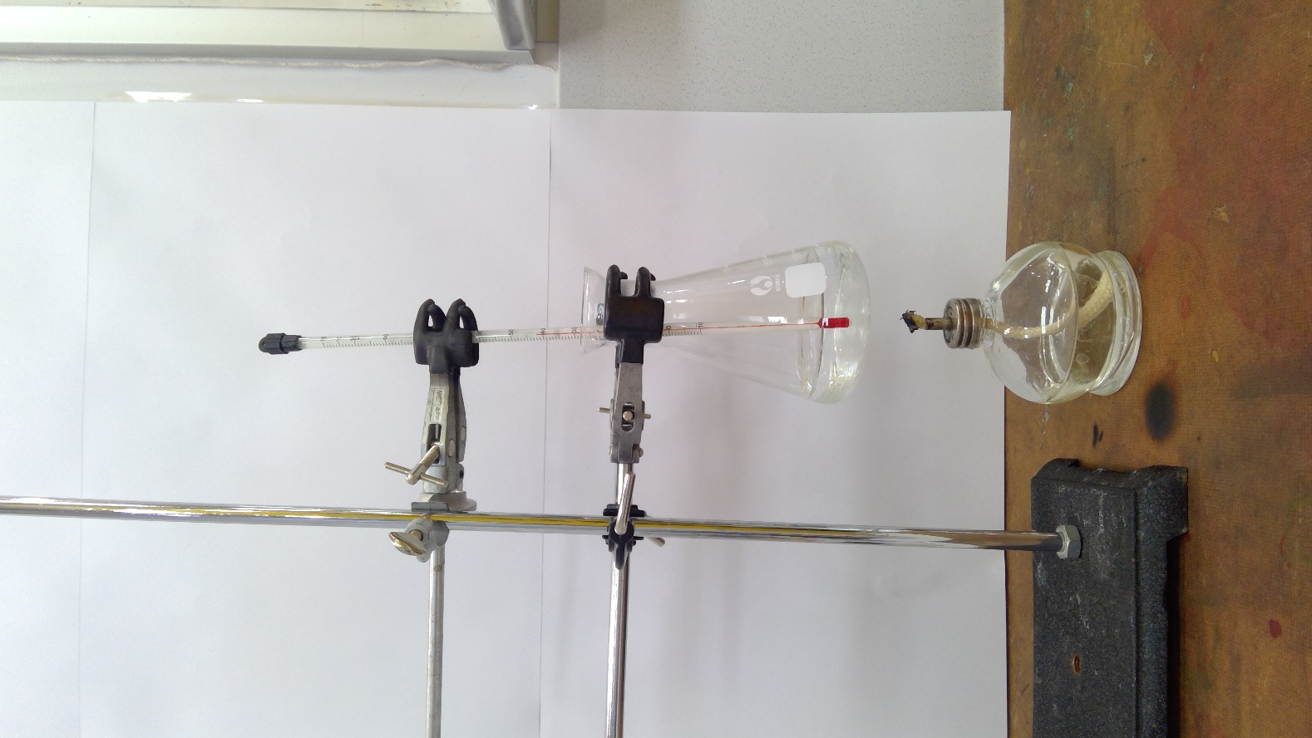
- Measuring cylinder
- Thermometer
- Electronic balances
- Spirit burners with wicks & caps,
containing the alcohols
- Matches

Chemicals
- Methanol (HIGHLY FLAMMABLE, TOXIC)
- Ethanol (HIGHLY FLAMMABLE)
- Propan-1-ol (HIGHLY FLAMMABLE, IRRITANT)
- Butan-1-ol (FLAMMABLE, IRRITANT, HARMFUL)

Procedure
- Measure 100 mL of cold tap water into a conical flask (Prepare x3).
- Clamp one flask at a suitable height so that a spirit burner can easily be placed below. This distance will need to be consistent across the whole class.
- Weigh the spirit burner (and cap) containing the alcohol and record this mass and the name of the alcohol.
- Record the initial temperature of the water in the flask.
- Light the burner
- Place the spirit burner under the flask and light the wick.
- Allow the alcohol to heat the water so the temperature rises by about 60°C (starts at 20°C) and reaches a final temperature of 80°C.
- Once optimum temperature is reached, extinguish flame by replacing the cap.
- Re-weigh the spirit burner and cap and record this mass. Work out the mass of alcohol used (this is required to work out the amount of energy produced per gram).
- Using a fresh 100 mL of cold tap water, repeat the experiment with the other alcohols.
- Repeat the experiment 3 times for each alcohol so an average can be determined

